Year 7 Science - laboratory Safety & Equipment
Name: |  | __________________________________________ | Date:____________
Class: |  | ______________________
Instructions to students: Please write answers in spaces provided.
Multiple choice questions |  |  | /25 Marks
1 | If someone’s clothing or hair accidentally catches on fire the first thing you should do is:  A put your hand up and tell your teacher  B get to the telephone and ring for the fire brigade.  C get the person to lie on the floor and cover them with a fire blanket or other clothing.  D tell them to run to the front office to get first aid.  Answer:___ |  |  | 1
2 | The correct order to follow when lighting a Bunsen burner is to light a match with the:  A air hole is open and the gas is turned on.  B air hole is closed and the gas is turned off.  C air hole is closed and the gas is turned on.  D air hole is open and the gas is turned off.  Answer:___ |  |  | 1
3 | If you accidentally pick up something hot and burn your fingers, the first thing you should do is to:  A put your hand up and tell the teacher.  B put your hand in your pocket so the teacher does not know what happened.  C put your hand under warm running water.  D warn your partner so it does not happen to them.  Answer:___ |  |  | 1
4 | Which one of the following statements is incorrect?  A If you open the air hole of a Bunsen burner the colour of the flame will change from blue to yellow.  B The yellow flame of a Bunsen burner is not as hot as the blue flame.  C A Bunsen burner is used to heat liquids and solids in science lessons.  D The Bunsen burner flame heats things faster then a candle flame.  Answer:___ |  |  | 1

5 | The flame of a Bunsen burner should be extinguished/ put out by:  A slowly opening the air hole.  B blowing it out.  C closing the air hole.  D turning off the gas tap.  Answer:___ |  |  |  | 1
Short answer questions |  |  | Marks
6 | Write the name of the piece of laboratory equipment in the space provided.  Correct spelling is important.  Answer:____________________ | 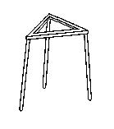 |  | 1
7 | Write the name of the piece of laboratory equipment in the space provided.  Correct spelling is important.  Answer:____________________ | 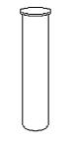 |  | 1
8 | Write the name of the piece of laboratory equipment in the space provided.  Correct spelling is important.  Answer:____________________ | 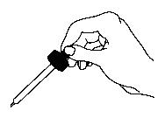 |  | 1
9 | Write the name of the piece of laboratory equipment in the space provided.  Correct spelling is important.  Answer:____________________ | 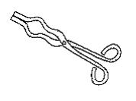 |  | 1
10 | Write the name of the piece of laboratory equipment in the space provided.  Correct spelling is important.  Answer:____________________ | 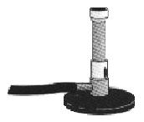 |  | 1
11 | Write the name of the piece of laboratory equipment in the space provided.  Correct spelling is important.  Answer:____________________ | 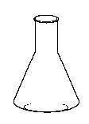 |  | 1
12 | Write the name of the piece of laboratory equipment in the space provided.  Correct spelling is important.  Answer:____________________ | 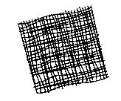 |  | 1
13 | Write the name of the piece of laboratory equipment in the space provided.  Correct spelling is important.  Answer:____________________ | 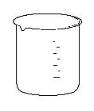 |  | 1
14 | Write the name of the piece of laboratory equipment in the space provided.  Correct spelling is important.  Answer:____________________ | 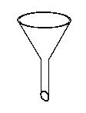 |  | 1
15 | Write the name of the piece of laboratory equipment in the space provided.  Correct spelling is important.  Answer:____________________ | 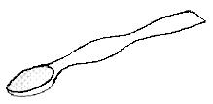 |  | 1
16 | Select from the list, the best equipment to do the task.  test tube tripod  tongs dropper  Bunsen burner gauze mat  flask beaker  funnel spatula  (a) Holding a piece of metal in a flame to see if it burns.  Answer:_________________________________________  (b) Pouring a liquid safely from a large beaker into a flask.  Answer:________________________________________  (c) Picking up a small amount of a solid.  Answer:_______________________________________ |  |  | 1  1  1
17 | To heat a liquid quickly you should use a blue flame.  True or False? Answer:____________________ |  |  | 1
18 | To heat a liquid slowly you should use a yellow flame:  True or False? Answer:____________________ |  |  | 1
19 | The reason you use a heatproof mat is to prevent damage to the laboratory bench  True or False? Answer:_____________________ |  |  | 1
20 | A beaker should be used to measure the volume of a liquid accurately.  True or False? Answer:_____________________ |  |  | 1
21 | 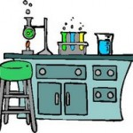  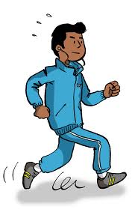  What is the laboratory safety problem in the picture, describe a rule which would make this safe.  Problem  ________________________________________________________________  ________________________________________________________________  ________________________________________________________________  Safety Rule  ________________________________________________________________  ________________________________________________________________  ________________________________________________________________ |  |  | 1  2

